Digital tenders at Menigo
Starting in September 2019, Menigo only accepts assortment revisions through our digital tool (a.k.a. Newton).
Revsions includes new items, changed items and de-listed item.
With a few exceptions revisions will only be accepted at specific times; for foodservice and equipment it is the first Monday of February, May, September and November.
Revisions should be advertised at least 12 weeks in advance.
Please note that all equipment quotes MUST have “VCD Restaurant Equipment” attached UNLESS you send electronic AI through Valdioo/GS1. (more information below)
At this point the tool is only available in Swedish. This manual aims to guide you through the process.

Log onto Menigos Supplier portal with your usual account.
The supplier portal support information in English.
Choose the function Assortment revision.

Start page
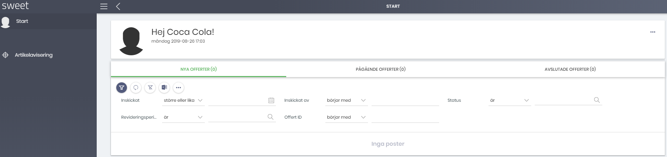
On the start page you will see your earlier quotes.
Under Nya offerter there are those that Menigo has not yet started working on.
Under Pågående offerter there are those that Menigo has started reviewing.
Avslutade offerter är closed
Export of earlier material
To export everything, you see on the screen (for example, all pending quotes or all rows in the quotation you have opened) press the Excel symbol (second from the right). You can choose to export to an Excel file or email. If you choose to email, the Excel file will appear as an attachment.
You cannot change or adjust anything when the quote is submitted. If you miss a detail or need to make a minor adjustment - contact your category manager. This also applies if for some reason you want to remove the entire quote and start from the beginning.
If you forgot to send with articles you can send a supplementary quote. The quotation you have already submitted will not be overwritten, but you will have two quotation IDs for the period.
Any changes in prices or discounts that you and Menigo agree will not be displayed.

Post a quote
To place a quote / article notification, click Artikelavisering on the left.

If you have not already filled in the quotation template, you can download it here (in Swedish only), click on Download template. The template contains information about what is mandatory to fill out.

When you have a ready notification to send, click Importera artiklar. Find your file and import.

The rows you imported are now visible on the screen.

Rows that are incorrect or incomplete will appear as red. You get some info under Status about what's wrong.

You must correct or delete the incorrect lines in order to submit your quote!

Adjust the errors in your Excel file and import it again. As long as you have not submitted the notification, you can repeat this as many times as you want / need.

(The most common errors are that a required field is missed or the format is incorrect.)

Attachments
Please note that all equipment quotes must have additional information in the workbook “VCD Restaurant equipment Menigo”.
You may also add other attachments to your notification, such as a presentation material.
You need to do this BEFORE you press submit to link the material to the quotation.
Just click Bifoga fil and upload your document (s).
Submit
When the notification is correct, click Submit.
You will see a box where you enter your email address. Then we know who at your company has submitted the quotation and should be contacted by our category organization.
Please also indicate the period of notification. Please note that Fastlane may ONLY be used on the invitation, ie when Menigo requests a quote on a request from a customer.
The screen shows confirmation that everything has gone well.
As long as you do not submit, your lines will remain under articles, even if you log out. The lines are inaccessible to Menigo, so it is important that you submit in order for your material to progress. Now you're done.
If necessary, the category organization will contact you.
If you have any questions concerning the administration and functions in this tool, please send a mail to melvin@menigo.se and we will get back to you as soon as possible.

